案例研究：腋下的真菌感染

這是感冒廚房圖表-檸檬的外治用法，原信件內容為英文，謝謝陳彥成醫師的翻譯。

真菌感染若是使用抗菌消炎藥物引起，務必停止使用才能痊癒。

2/26:

嗨，張醫師,

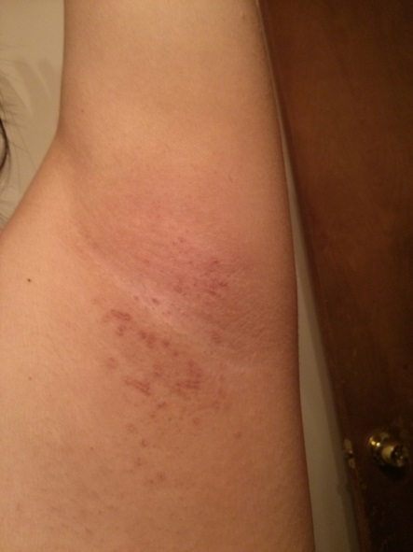
我敢肯定，我的兩側腋下，有一種真菌感染。已經有一段時間了..它時來時去。我附上一張它的照片。我可以使用抗真菌霜乳液嗎？或者我應該用一種更自然的方法來治愈它呢？我是否應該吃某種食物，讓我的身體更不容易受到真菌感染嗎？ （在夏天，也有白色斑點在我的身體，也由於一種真菌感染。）

如果是忙不過來回應，我完全能理解！謝謝你做的一切！

S.L.

2/26

嗨，

*如果可能的話，應避免使用抗真菌霜劑。相反地，嘗試用檸檬汁。

*保持受影響的部位乾燥（如出汗或洗澡後）以加速癒合。註：可用吹風機

*感染可能是由於你正在使用的除臭劑（除臭劑）/止汗劑（防汗劑）。請嘗試換另一個使用更多的天然成分的品牌。

張醫師診所，

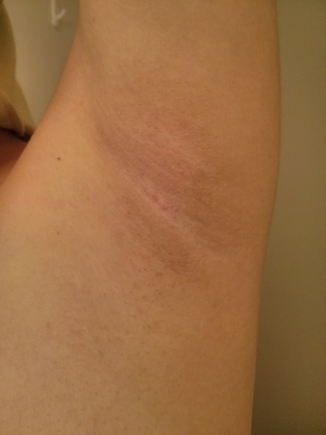

3/2

嗨，張醫師,

我只是做了你告訴我做的。我停止使用我的除臭劑，並在運動/淋浴後，保持腋下乾燥。我每天切一片檸檬，擦拭腋下，然後讓它乾。（也許是每隔一天，有時我會忘記做）

幾天後，大部分的感染都消失了！謝謝你告訴我可以用檸檬汁擦拭，效果真是令人驚訝。:)

S.L.

Dermatitis (1) : Fungal Infection of the Armpit

2/26 :

Hi Dr. Jang!

I'm pretty sure I have a fungal infection on both sides of my armpits. I've had it for a while.. it comes and goes. I attached a picture of it. Can I use an anti-fungal cream on it? Or should I use a more natural method to cure it? Is there a certain food I should eat that would make my body less prone to fungal infections? (I also have white spots on my body during summer when I tan due to a fungal infection too.)

I totally understand if you are too busy to respond! Thank you for everything!!

S.L.

2/26 :

Hi ,

* Avoid using anti-fungal cream if possible. Instead, try applying lemon juice.

* Keep the affected area dry (like after sweating or showering) for faster healing.

* The infection may be due to the deodorant (除臭劑) / antiperspirant (防汗劑) you are using. Please try switching to a brand that uses more natural ingredients.

Jang's office

3/2 :

Hi Dr. Jang,

I only did what you told me to do.. I stopped using my deodorant, and I kept it dry after exercising/showers. I cut a slice of lemon and rubbed on there every day and then let it dry. (Maybe it was every other day.. I would forget to do it some days.) Most of it went away after a couple of days! Thank you for telling me to put lemon juice on it! It's really amazing how that works. :)

S.L.

